Name: Class:
Introduction
As measuring instruments became more sensitive, the evidence from ionisation energies and other measurements revealed a level of detail in electron arrangements that could not be explained simply in terms of simple shells. Coupled with the emerging field of quantum mechanics, it was necessary to introduce a finer structure of the atom – subshells and orbitals.

The principal quantum number, n, refers to the shell that an electron occupies. An electron with the quantum number n = 1 is in the lowest energy shell – the first shell. On average, this electron is closer to the nucleus than electrons in shells of higher energy (n = 2, 3…). The electron in the lowest energy shell is the most strongly attracted to the nucleus and the hardest electron to remove during ionisation reactions.

Shells are split into subshells. The extent of the split depends on the principal quantum number. For n = 1, there is no split. For n = 2, the shell is split into two subshells. For n = 3, there are three subshells. The subshells within a shell are given a letter designation. The first subshell in each shell is designated as s, the second as p, the third as d, and the fourth as f.

Finally, quantum mechanics also defines the region of space in which an electron of a particular energy can be found. These regions of space are called orbitals. No matter what the energy of the electron happens to be, an orbital can contain no more than two electrons. Table 1 provides an overview of the shells, subshells and orbitals in an atom.

Table 1
Principal quantum number, n ( shell number) | Subshell designation | Number of orbitals | Maximum number of electrons in the subshell | Number of electrons in each shell (2n²)
1 | s | 1 | 2 | 2
2 | s | 1 | 2 | 8
2 | p | 3 | 6 | 8
3 | s | 1 | 2 | 18
3 | p | 3 | 6 | 18
3 | d | 5 | 10 | 18
4 | s | 1 | 2 | 32
4 | p | 3 | 6 | 32
4 | d | 5 | 10 | 32
4 | f | 7 | 14 | 32

What this table does reveal is that with the exception of the first shell, all the shells consist of more than one subshell. Each subshell has a different energy with the order of energy being s < p < d < f in any shell. Thus it is possible that a subshell in a shell with a higher value of n can overlap, i.e. have a lower energy than, a subshell in a shell with a lower value of n. In fact, it is observed that the 4s subshell energy is lower than that of the 3d. In other words, two electrons will go into the 4s subshell before the 10 electrons (and 10 elements) complete the 3d subshell. This is shown diagrammatically below.

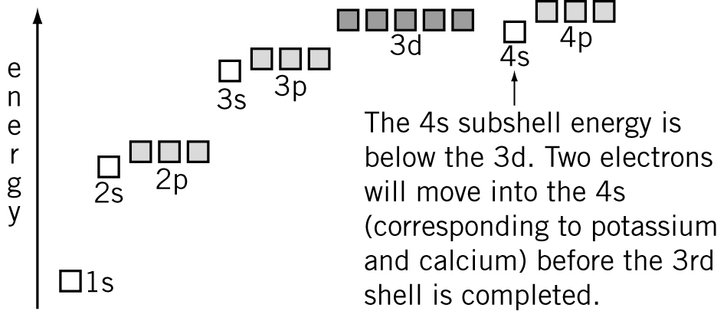

Order of shell, subshell and orbital energies

The electron configuration of an atom shows the arrangement of electrons in the orbitals of the atom. To determine the electron configuration of an atom in its lowest state (or ground state), the following principles are used:
• Place electrons into orbitals starting with the lowest energy orbitals first.
• Place a maximum of two electrons in each orbital.

The shorthand method used to describe the arrangement of electrons in an atom is as follows:
• First, the shell number is written as a ‘large’ number.
• The subshell letter is written next.
• Then, the number of electrons in the subshell is written as a small superscript.
For example, if an atom of magnesium has 12 electrons, its electron configuration would be written as 1s² 2s² 2p⁶ 3s².

No. | Question | Answer
 | Assuming the pattern implied in Table 1 continues, predict how many subshells are likely to be found in the fifth shell, and how many orbitals will be present in each of these subshells.
Using the s, p, d notation, give the electron configuration of the following atoms.
a oxygen
b potassium
c bromine
d iron
e copper
Give the electron configuration, in s, p, d notation of the following ions.
a Mg²⁺
b S^{2–}
c fluoride ion
d calcium ion
e aluminium ion
f bromide ion
Identify the following elements.
a An element with the electron configuration 1s²2s²2p¹
b A period 3 element with three full and one half-full subshell
c An element whose –2 ion has gained enough electrons to complete the second shell
d An element with six full orbitals only
Give the electron configuration, in s, p, d notation of an element in:
a period 2, group 2
b period 3, group 14
c period 4, group 18.
The periodic table is often divided into blocks as shown.

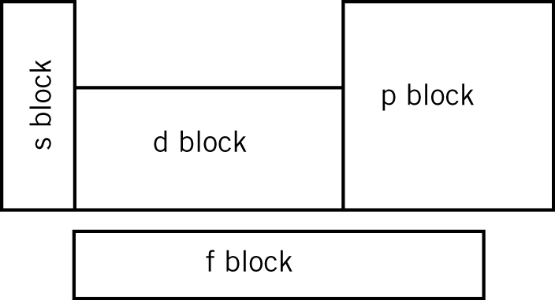

a After considering the electron configurations of magnesium, potassium, iron, copper and oxygen, describe the similarity in the electron arrangement of the elements in the:
i s block
ii d block
iii p block.
b Predict the common characteristic about the electron arrangements of the elements in the f block.

